MOVIE NIGHT !!!!!!!
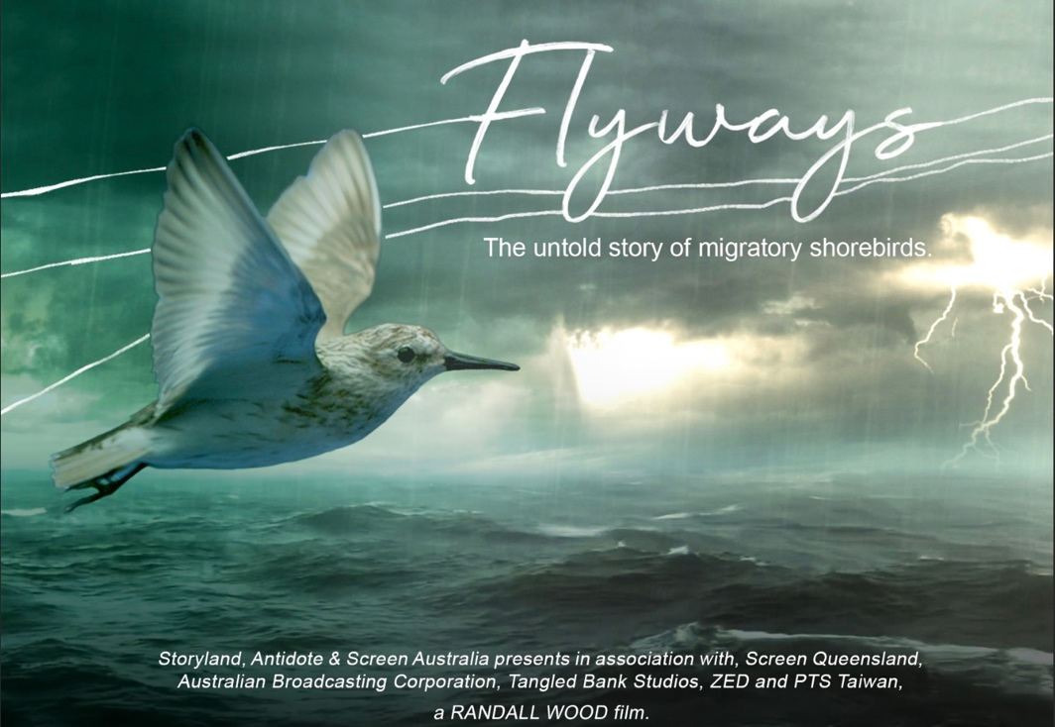
You are invited to:
What : World Premiere of the movie, “Flyways”,
hosted by Birdlife Southern Queensland.
Flyways will utilise the best science to address the harsh reality of the extinction crisis looming for many migratory shorebirds. However, importantly it will tell stories of the positive action we can take to stem the tide – on a local and global level.
The film showcases the very latest tracking technologies from the international space station, never-before-seen phantom footage of shorebirds in flight from a world-class wind tunnel, & innovative drone footage of extraordinary landscapes.
There will be an introduction to the movie with a glass of wine and delicious nibbles before the movie commences.
Where: Majestic Cinemas, Wynnum, 82 Berrima St, Wynnum
When: Sat 6 May, 2023, 5.00 pm - 8.30pm
How to purchase your ticket:
https://wynnum.majesticcinemas.com.au/movie/flyways
Cost: $25.00 (concession)- $35.00(adult)
Flyways will also be screened at New Farm Cinemas at 4.30pm on May 7th:
https://fivestarcinemas.com.au/new-farm/movie/flyways
We would love to meet up with you at the launch!

